# Preparation and planning

**Working title**

"A Web-Based Application to manage bookings for lessons of Sign Language for Children with Autism."

**Description and scope**

My girlfriend is looking for a software solution, that will help her manage bookings for her business: teaching sign language for children with autism. Lessons will take place online, and she wants a reliable system for managing bookings where users will be able to book learning sessions.

Without booking system, it could be harder to manage and schedule learning session, as manual booking system can be time-consuming. It can also be difficult to create good user experience without platform that streamline booking features.

Main benefits of booking system are ability to track and manage bookings, increase user experience, and help with timesaving. It can also help with scaling the business, as Firebase cloud services will be able to increase service when needed, without much of admin attention1.

The key ICT aspects is managing booking with specific date and hour, such as creating, changing, and deleting learning sessions. Another key ICT aspects is user-friendly interface, centralized database for storing booking information, confirmation emails and questionnaire about lessons. Database will need to storage learning materials. Application will also include information about business and contact features.

My existing knowledge for creating Web-based booking system is mainly within front-end aspects of creating websites and using back-end functionalities. I think I have a good understanding of how positive user experience should be shaped, but I will need to study more deeply use cases of successful booking systems.

The solution will be a fully-fledged Web-based Booking Application, that will allow users to book and manage their sign language lessons and give admin options and relevant functionalities to business owner.

My solution to the problem presented will be within my Software Development route. During the duration of my studies, I was exposed to different programming languages and concepts. I believe that knowledge and skills that I acquired will be helpful in the project. I will use by TM352 Web, mobile and cloud technologies with some elements of TM356 Interaction Design and the User Experience. It will be Web-based application for Booking system, written in React, styled in SASS, and connected to Firebase.

My application will be done using my version of Prototyping Model with Iterative Approach2, 3. It will be a mix of these two approaches, tweaked a little to be more appropriate for the project.

Initially, I will be evaluating the project by talking to my girlfriend and refining based on feedback, as I have room with iteration approach. Evaluation method still need to be decided and will be explored very deeply in Evaluation Phase. It will be some sort of user testing.

**Major tasks and subtasks**

**Research Phase Iteration 1 (30 hours):**

* Define project scope (5 hours)
* Define project resources (5 hours)
* Choose lifecycle model (5 hours)
* Conduct literature research (10 hours)
* Finish learning React and Firebase (5 hours)

**Research Phase Iteration 2 (20 hours):**

* Read and analyse TMA02/relevant study materials (5 hours)
* Conduct market research (10 hours)
* Make changes based on tutor feedback (5 hours)

**Design Phase Iteration 1 (20 hours):**

* Create rough sketches of user interface (5 hours)
* Create a low-fidelity prototype (10 hours)
* Discuss design with stakeholder (5 hours)

**Design Phase Iteration 2 (10 hours):**

* Refine the design based on feedback from the previous iteration (10 hours)

**Software Phase Iteration 1 (25 hours):**

* Set up React Project and build routed component Information, Booking, Contact and Admin page components (10 hours)
* Style the pages using SASS (10 hours)
* Connect App.js to Firebase (5 hours)

**Software Phase Iteration 2 (30 hours):**

* Read and analyse TMA03/relevant study materials (5 hours)
* Create Firebase project and set up Firebase database and determine data structures for appointments, users, resources, and questionnaire responses (10 hours)
* Create data structures for appointments, users, resources and questionnaire responses (5 hours)
* Implement user authentication with Firebase (5 hours)
* Present, discuss and refine based on stakeholder input (5 hours)

**Software Phase Iteration 3 (20 hours):**

* Implement add, edit, delete, and view appointment feature for both users and admin (5 hours)
* Add post-training questionnaire features (5 hours)
* Design post-training questionnaire (5 hours)
* Implement functionality to send questionnaire via email (5 hours)

**Software Phase Iteration 4 (20 hours):**

* Store questionnaire responses in Firebase database (5 hours)
* Implement functionality for admin to view questionnaire responses (5 hours)
* Add resource database and email notification features (5 hours)
* Implement functionality for admin to add and delete resources (5 hours)

**Software Phase Iteration 5 (30 hours):**

* Implement functionality for users to download resources (5 hours)
* Implement email notification feature for appointment reminders and questionnaire reminders (5 hours)
* Test the application (10 hours)
* Fix any bugs found during testing (10 hours)

**Evaluation Phase (20 hours):**

* Define evaluation criteria and goals (5 hours)
* Identify evaluation methods (5 hours)
* Develop plan for conducting evaluation method (10 hours)

**Software/Evaluation Phase (30 hours):**

* Conduct user testing with stakeholder (5 hours)
* Analyse and document results of the testing, identify strength and weaknesses (5 hours)
* Evaluate results against evaluation criteria (5 hours)
* Refine the design based on feedback (10 hours)
* Report evaluation findings (5 hours)

**Report Writing Phase (40 hours):**

* Analyse previous TMAs and study materials (5 hours)
* Write about problem description and context (5 hours)
* Write about related literature (5 hours)
* Write about analysis, synthesis and evaluation (5 hours)
* Write about review of current stage of project work (5 hours)
* Write about review of project management (5 hours)
* Write review of personal development (5 hours)
* Create Epilogue, References and Appendices (5 hours

**TMA writing phase tasks**

* Write TMA01 (10 hours)
* Write TMA02 (10 hours)
* Write TMA03 (10 hours)

**Mapped tasks**

**Lifecycle model and schedule**

**Chosen model: Prototype Model with Iterative Approach**

I will use Prototype Model with Iterative Approach. It is a mix of Iterative Approach and features that are taken from Prototype Model in Software Engineering and tweak to my needs4, 5. It will involve creating a working prototype, which will be built, tested, and recheck over time. The goal is to create initial prototype, that will be gradually worked on in each iteration.

Project scope and requirements are well discussed and approved by both parties. Prototype will be built in iterative way based on these requirements.

I have high confidence in tackling project activities, and I think I have good understanding of each task that needs to be taken. This would help me in creating prototype, by adding more functionalities in each iteration.

I will be dependent on my girlfriend in terms of approving a layout design, and iterative approach in building working prototype will help to take my girlfriends suggestions and used them to refine layout in next iteration.

The biggest key constraints are imposed by Firebase, like free usage threshold6. Prototype Model with Iterative approach will help me to focus on each functionality made in Firebase separately, which will help me to follow specific rules.

There is really no benefit in delivering a partial solution, as a project will be small, closed system of irreplaceable components. I will be able to create it, by adding each functionality in small steps using Prototype Model with Iterative Approach.

This approach provides good organisation and helps manage project more clearly. There are no High risks in my project, and overall project leans more towards low risks than medium risks.

**Alternative model: Incremental Approach**

The alternative that I was thinking about was Incremental Approach7.

As stability of the project is high, Incremental Approach will not be very useful, as it is more suitable for projects that are likely to change over time.

I have high confidence in tackling the issue, but Incremental Approach could help me spot problems early, which can help to mitigate risks. It provides good control over the project, as it is developed in small bits.

I will be partially dependent on my girlfriend, and incremental approach could help me to build the project and design the layout in incremental steps, building on conclusions from other iterations.

Following Firebase rules is the key constraint, and Incremental Approach could help me with respecting Firebase rules strictly, as each time I would be working on small functionality.

Delivering a partial solution is not beneficial in this case, as developed application is a small project. Each part can be built on top of others, built in earlier incremental steps.

**Resources, skills, and methods**

**Project resources**

**Documentation and Writing tools:**

I will use Word Office and Evernote for documenting my progress and writing notes. Word Office will be mainly used for writing assignments and reports, while Evernote will be used for day-to-day writing activities. I have acquired both resources. Evernote is available through website, while Word Office is already downloaded on my PC.

**Design and Prototyping tools**

I will use Diagram Editor and Figma. Diagram Editor is free online tool available on the Internet, that will be needed for creating diagrams and flowcharts for my project. Figma is a prototyping tool, that will be used for creating design for my website, before I start to code. I will be using free version, which is available online.

**Project Management tools:**

I will use Trello for organizing my tasks in Kanban board. This project management tool is having free subscription provided online. able

**Code and Version Control tools**

I will use Visual Code Studio for writing my code. It has free version and is already download on my PC. Git and GitHub will be used for version control and backing of my code, they are also available for free. GitHub will be used online, while Git is already installed on my Ubuntu system.

**Project methods**

**React**

I will be using React, which is a JavaScript library for building website application. It is a very popular, modular, and flexible web development approach. It is also well supported by Facebook and have good documentation8. I will be using functional approach with Hooks.

**SASS**

I will also use SASS, a CSS pre-processor for styling website. It gives a lot of new functionalities, which make it easier to create and maintain styles9. Main alternative could be LESS10, but I have more experience with SASS, and I am more confident in using it.

**Firebase**

Lastly, I will use Firebase for all cloud services needed (authentication and cloud storage). It provides very user-friendly approach to use cloud services, that are scalable and flexible. It also has very good documentation on the official website, with plenty examples and is supported by Google. I will be using Firebase Authentication (for login), Firestore Cloud (for storing data) and Firebase Security Rules.

**Project skills**

I am confident in my programming skills, and I have good understanding of programming languages like Java, JavaScript, and Python. I have finished reading documentation about React and Firebase and experimented with the code. It looks straightforward, and if unsure, I can always check it against official documentation. In terms of SASS, I was using it in couple projects already, so I am confident in my skills.

**Project work**

**Information sources – the literature**

*Siyal, A.W., Hongzhuan, C., & Gang, C. From consumer satisfaction to recommendation of mobile app–based services: An overview of mobile taxi booking apps*11*.*

This article was selected from Google Scholar when I was looking for articles about user interfaces. It will be useful to understand what shapes consumer satisfaction and how to adjust it to my project during Research Phase. It has 12 citations on Google Scholar.

*Molina-Ríos, J., & Pedreira-Souto, N. Comparison of development methodologies in web applications*12*.*

This article was found on Google Scholar when I was looking for articles related to React and Firebase development. It could be useful as inspiration for approach my project management from different angle and adjust it if needed during Software Phase. It was cited 32 times on Google Scholar.

*Miraz, M.H., Ali, M., & Excell, P.S. Adaptive user interfaces and universal usability through plasticity of user interface design*13*.*

This article was found on Google Scholar when I was researching topic of user design and user interfaces. It will be useful, because I will be able to use it for adjusting user interface to be more adaptive during Research and Design phase. It was cited 43 times in Google Scholar.

*Paz, F., & Pow-Sang, J.A. A systematic mapping review of usability evaluation methods for software development process*14*.*

This article was found on Google Scholar while researching topic of evaluation methods. It will be useful to help me decide which evaluation and testing methods to choose when reviewing my project in Evaluation Phase. It was cited 133 times on Google Scholar.

*Wesley, J., Fifilia, , Catrine, C., Antony, D., & Estefan, F. R. Model design to develop online web based questionnaire*15*.*

This article was found in Academic Search Complete database, when I was looking for something related to creating questionnaires. It can point me into a right direction when designing questionnaires in Software Phase. It was found in Academic Search Complete database.

*React Official Documentation and Firebase Official Documentation*16, 17*.*

These two documentations are known to me very well, as I am constantly consulting my React and Firebase coding and problem solving with them. These official documents will be extremely useful, as they have all necessary knowledge of React and Firebase. It is credible source, as React and Firebase are developed by Facebook and Google.

*Staiano, F. Designing and Prototyping Interfaces with Figma*18*.*

This article was found in O`Reilly database during search of prototyping my project. It will be useful for Design Phase when I will be creating low-fidelity prototype. It is a respected source, as it was found in O`Reilly database.

**Discarded literature:**

Discarded literature ended up here because of their lack of relevance to my specific needs and project. They either focus on different aspects of what I am doing in the project or are wrongly identified by me as potentially useful but turns to be about different topic. They were found in Google Scholar and O`Reilly database.

* Santos, G., Mota, V.F.S., Benevenuto, F., et al. (2020). *Neutrality may matter: sentiment analysis in reviews of Airbnb, Booking, and Couchsurfing in Brazil and USA*. Social Network Analysis and Mining.
* Williams, T., Vo, H., Samset, K., & Edkins, A. (2019). *The front-end of projects: a systematic literature review and structuring*. Production Planning & Control.
* Post, D. E., & Kendall, R. P. (2021). *Creating and Using Virtual Prototyping Software: Principles and Practices.* Addison-Wesley Professional.

**Project work**

**Functional requirements**

* User will be able to book, view, change and delete own booking for a specific date and time.
* User will be able to create own account, log into it and access services relevant to him, such as downloading materials and managing booking.
* Admin will be able to log as admin, get services that user has, plus change and delete bookings of all users.
* Admin will be able to upload learning materials for user to download.
* User will have ability to create account either by email, or sign-in with social media account.
* Users and admin accounts will be stored in Firebase and will be accessible through login authentication.
* User will be able to read information about the business and contact Admin.
* User will receive confirmation email after successful booking.
* Booking System will send questionnaire about lesson on user email after booked session is duel.

**Non-functional requirements**

* Booking system should provide good user experience.
* It should be accessible.
* It should be scalable.
* It should be secured.

**System overview**

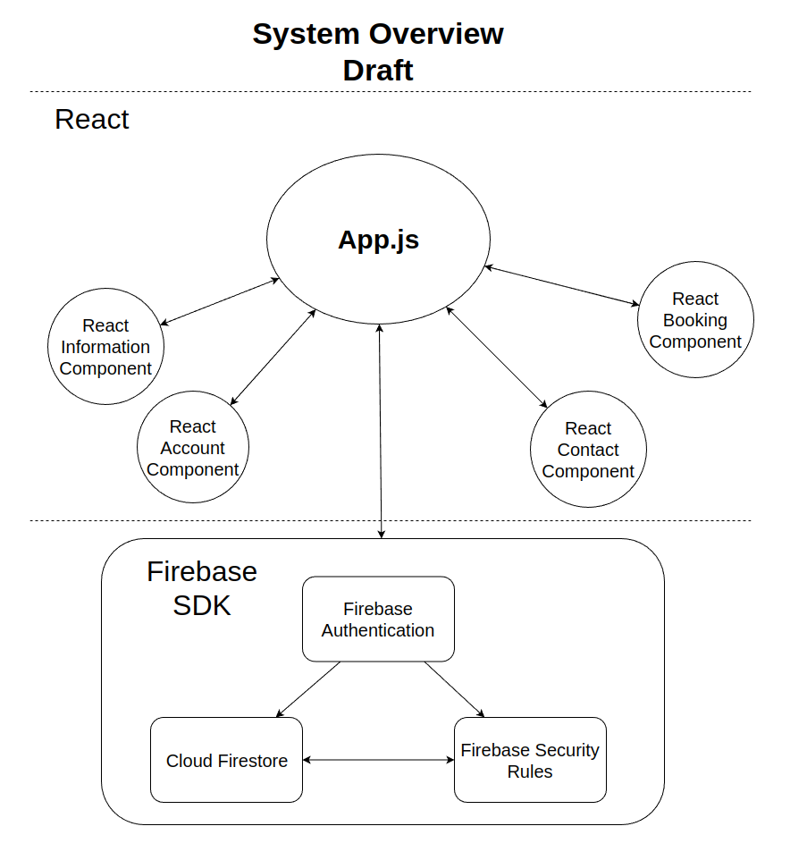

Front-end technology will be React. Main component, App.js, handles defining the structure of the page, routing React components, displaying content based on information provided by React components, managing state of the application, creating connection to Firebase SDK, and handling input and output to and from Firebase SDK. Four React components are responsible for handling their responsibilities to provide necessary information to App.js about what needs to be rendered and displayed. They will not connect to each other directly.

Back-end technology will be Firebase. Firebase SDK will provide output from Firebase Authentication, Cloud Firestore, and Firebase Security Rules to App.js. Firebase Authentication will manage user authentication, authorization, and sign-in. Cloud Firestore will be responsible for storing and managing data from App.js. Firebase Security Rules will process authentication tokens from Firebase Authentication and check level of permission. Additionally, Firebase Security Rules will determine level of access to Cloud Firestore, which will provide data for Firebase Security Rules to check against its access rules.

**Review and reflection.**

I have done good progress over the course of last month. I have installed all necessary software, read and analyse study guides, and make myself familiar with the technologies and tools needed. Requirements of the Booking system were also discussed several times with my girlfriend and agreed to. Based on this, I have developed detailed plan containing all necessary tasks that are mapped to help me with progress development. Additionally, I have read and studied official documentation on Firebase and React. I have chosen Lifecycle Model and alternative, and I think they will fit into my project. Lastly, I have made Literature Search and create initial work for project itself, which are requirements and diagram for system overview.

During my preparations, I have come across some problems. It took me longer than expected to analyse TMA01 and relevant study materials, I had an unexpected job interview that delayed my progress, and I had difficulty to provide good time indication for each task. These were major issues that are likely to recur. Also, I did my literature search and chose lifecycle model shortly before my TMA01, so I was not able to evaluate it properly. To mitigate these risks, I have allocated more time for TM470 related activities, map tasks of study materials early on after finishing TMA and create detailed tasks with time allocation to follow my progress.  The last risk mitigation will especially help with issue of not following up on what I scheduled. In addition, I was also more generous with time allocation on each task that I initially thought, which should be helpful when tackling unexpected issues. I have chosen React, SASS and Firebase technologies, as they are well understood, modern and user friendly in terms of writing code.

I was developing my necessary skills by reading official documentation of React and Firebase, as well as finishing React course on The Odin Project website19. I have good understanding of JavaScript, Java, Python, as well as HTML, CSS, and SASS.  I was also experimenting with React and Firebase. I have good knowledge of programming concepts.

To mitigate the risks, I have decided to use React, Firebase and SASS technologies, because they have extensive documentation and plenty of examples of usage on official websites. Moreover, I have divided my tasks and create risk assessment of potential issues. A project approach will help me in tackling these tasks. I will also contact my tutor every time I will need advice. My last resort will be increasing hours studied temporarily (and very occasionally) if everything else fails.

In terms of specific issues, I have following questions to my tutor:

* Is my project management approach good for this project?
* Is my project scope realistic?

I believe that my approach and scope is reasonable for the timescale, but I need second opinion of my tutor. Lastly, during conversation with my tutor I have change Project model, as previous one (Scrum) was suited more towards helping with communication between developers working on the project, which is inapplicable to my situation.

Overall, I am happy with my progress, and I am looking forward to next stage of TM470.

**Total words: 3249**

## References

1. Firebase, (2023). *Documentation. Developer documentation for Firebase.* [online] Available at: <https://firebase.google.com/docs> [Accessed 27.02.2023]
2. Martin, M. (2023). *Prototyping Model in Software Engineering.* [online] Guru99. Available at: <https://www.guru99.com/software-engineering-prototyping-model.html> [Accessed 27.02.2023]
3. Lewis, S. (2019) *Prototyping Model* [online] SearchCIO. Available at: <https://www.techtarget.com/searchcio/definition/Prototyping-Model> [Accessed 27.02.2023]
4. Martin, M. (2023). *Prototyping Model in Software Engineering.* [online] Guru99. Available at: <https://www.guru99.com/software-engineering-prototyping-model.html> [Accessed 27.02.2023]
5. Lewis, S. (2019) *Prototyping Model* [online] SearchCIO. Available at: <https://www.techtarget.com/searchcio/definition/Prototyping-Model> [Accessed 27.02.2023]
6. Firebase, (2023). *Firebase Security Rules*. [online] Available at: <https://firebase.google.com/docs/rules> [Accessed 27.02.2023]
7. JavaTpoint, (2021). *Incremental Model*. [online] Available at: <https://www.javatpoint.com/software-engineering-incremental-model> [Accessed 27.02.2023]
8. React (2023), *Getting Started*. [online] Reactjs. Available at: <https://reactjs.org/docs/getting-started.html>  [Accessed 27.02.2023]
9. Sass. (2023). *Sass: Syntactically Awesome Style Sheets*. [online] Available at: <https://sass-lang.com/> [Accessed 27.02.2023]
10. Less.js, *Getting started | Less.js*. [online] Available at: <https://lesscss.org/> [Accessed 27.02.2023]
11. Siyal, A.W., Hongzhuan, C., & Gang, C. (2021). *From consumer satisfaction to recommendation of mobile app–based services: An overview of mobile taxi booking apps*. Sage Open.
12. Molina-Ríos, J., & Pedreira-Souto, N. (2020). *Comparison of development methodologies in web applications*. Information and Software Technology, Volume 119, March 2020
13. Miraz, M.H., Ali, M., & Excell, P.S. (2021). *Adaptive user interfaces and universal usability through plasticity of user interface design*. Computer Science Review, Volume 40, May 2021.
14. Paz, F., & Pow-Sang, J.A. (2016). *A systematic mapping review of usability evaluation methods for software development process*. International Journal of Software Engineering and Its Applications, Vol.10, No. 1(2016), pp.165-178
15. Wesley, J., Fifilia, , Catrine, C., Antony, D., & Estefan, F. R. (2022). Model design to develop online web based questionnaire. Telkomnika, Vol. 20, 10.2022, 979-987
16. Firebase, (2023). *Documentation. Developer documentation for Firebase.* [online] Available at: <https://firebase.google.com/docs> [Accessed 27.02.2023]
17. React (2023), *Getting Started*. [online] Reactjs. Available at: <https://reactjs.org/docs/getting-started.html>  [Accessed 27.02.2023]
18. Staiano, F. (2022). Designing and Prototyping Interfaces with Figma. Packt Publishing.
19. The Odin Project. *Your Career in Web Development Starts Here | The Odin Project*. [online] Available at: <https://www.theodinproject.com/> [Accessed 27.02.2023]

## Appendices

## Risk assessment

|  |  |  |
| --- | --- | --- |
| **Task** | **Phase** | **Risk Assessment** |
| Define project scope | Research Phase Iteration 1 | Low |
| Define project resources | Research Phase Iteration 1 | Low |
| Choose lifecycle model | Research Phase Iteration 1 | Low |
| Conduct literature research | Research Phase Iteration 1 | Low |
| Finish learning React and Firebase | Research Phase Iteration 1 | Low |
| Conduct market research | Research Phase Iteration 2 | Low |
| Make changes based on tutor feedback | Research Phase Iteration 2 | Low |
| Create rough sketches of user interface | Design Phase Iteration 1 | Low |
| Create a low-fidelity prototype | Design Phase Iteration 1 | Medium |
| Discuss design with stakeholder | Design Phase Iteration 1 | Low |
| Refine the design based on feedback from previous iteration | Design Phase Iteration 2 | Medium |
| Set up React Project and build routed component | Software Phase Iteration 1 UI | Low |
| Style the pages using SASS | Software Phase Iteration 1 UI | Low |
| Connect App.js to Firebase | Software Phase Iteration 1 UI | Low |
| Create Firebase project and set up Firebase database | Software Phase Iteration 2 | Low |
| Create data structures for appointments, users, etc. | Software Phase Iteration 2 | Medium |
| Implement user authentication with Firebase | Software Phase Iteration 2 | Medium |
| Make sure that everything works with previous result | Software Phase Iteration 2 | Medium |
| Implement add, edit, delete, and view appointment features | Software Phase Iteration 3 | Medium |
| Add pre- and post-training questionnaire features | Software Phase Iteration 3 | Medium |
| Design pre-training and post-training questionnaire | Software Phase Iteration 3 | Medium |
| Implement functionality to send questionnaire via email | Software Phase Iteration 3 | Medium |
| Store questionnaire responses in Firebase database | Software Phase Iteration 4 | Medium |
| Implement functionality for admin to view questionnaire | Software Phase Iteration 4 | Medium |
| Add resource database and email notification features | Software Phase Iteration 4 | Medium |
| Implement functionality for admin to add and delete res | Software Phase Iteration 4 | Medium |
| Implement functionality for users to download resources | Software Phase Iteration 5 | Low |
| Implement email notification feature for reminders | Software Phase Iteration 5 | Medium |
| Test the application | Software Phase Iteration 5 | Medium |
| Fix any bugs found during testing | Software Phase Iteration 5 | Medium |
| Define evaluation criteria and goals | Evaluation Phase | Low |
| Identify evaluation methods | Evaluation Phase | Low |
| Develop plan for conducting evaluation method | Evaluation Phase | Medium |
| Conduct user testing with stakeholder | Software/Evaluation Phase | Low |
| Analyse and document results of the testing | Software/Evaluation Phase | Low |
| Evaluate results against evaluation criteria | Software/Evaluation Phase | Low |
| Refine the design based on feedback | Software/Evaluation Phase | Medium |
| Conduct user testing with stakeholder | Software/Evaluation Phase | Low |
| Analyse and document results of the testing | Software/Evaluation Phase | Low |
| Evaluate results against evaluation criteria | Software/Evaluation Phase | Low |
| Refine the design based on feedback | Software/Evaluation Phase | Medium |
| Report evaluation findings | Software/Evaluation Phase | Low |
| Analyse previous TMAs | Report Writing Phase | Low |
| Write about problem description and context | Report Writing Phase | Low |
| Write about related literature | Report Writing Phase | Low |
| Write about analysis, synthesis and evaluation | Report Writing Phase | Low |
| Write about review of current stage of project | Report Writing Phase | Low |
| Write about review of project management | Report Writing Phase | Low |
| Write review of personal development | Report Writing Phase | Low |
| Create Epilogue, References and Appendices | Report Writing Phase | Low |